**EXERCISE 4-SELECT with various clause – WHERE, pattern matching**

Q1

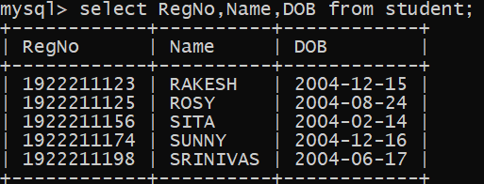

Q2

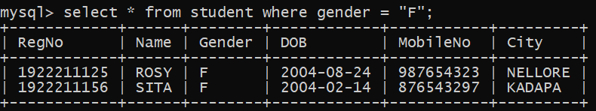

Q3

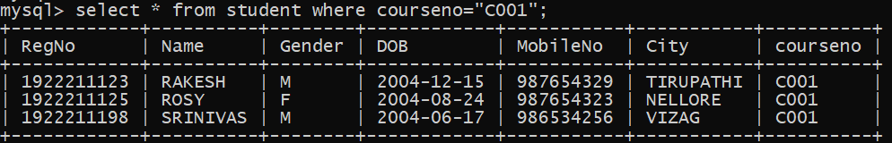

Q4

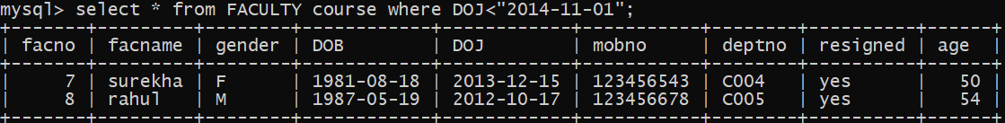

Q5

